Order Received (Shipped/Donated)

Congratulations! Your Girl Scout received an order that is being shipped directly to the customer and/or donated.
There isn’t anything you need to do (except remind your Girl Scout to send a Thank-You email), but here are things you will want to know.


Once you are in the Digital Cookie site, click the “Orders” tab to see what orders you received.


While you are in the site checking on sales, it’s a great time for your girl to add customers, send follow-up emails, complete badge work or explore the great girl tools on the website. She will probably pick up some good cookie program tips along the way!

.


On the cookie orders page, you can see all of the orders that have been received. Girls can see who purchased the cookies, how many, when, if they had them shipped or donated.

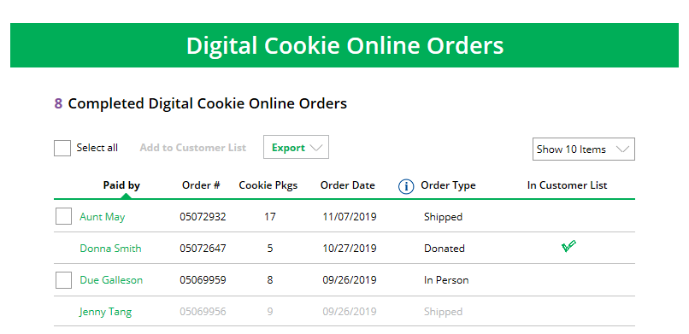



Clicking on the customer name for any of the orders will bring up details about what that customer ordered, including any donated boxes.

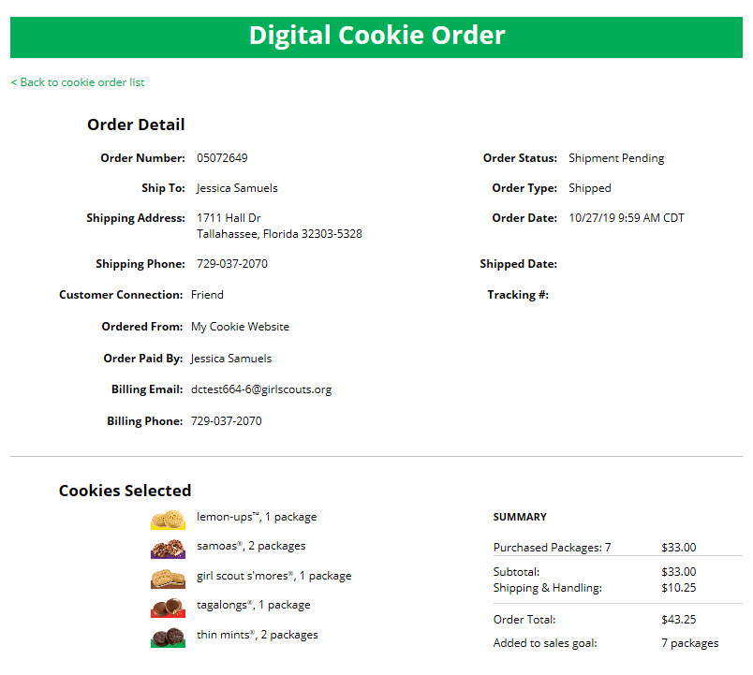
Your troop leader has instructions on how these sales get credited to the girls’ account automatically. But rest assured it is an automatic process and she gets credit for digital sales the same as any other cookie sale.

Don’t forget to have your Girl Scout send thank-you messages to make sure the customer becomes a repeat customer!


If the customer is not in her Digital Cookie contact list, your Girl Scout can check the box in front of the customer’s name and click “Add to Customer List.” Then, the customer will be in her records for sending thank-you emails this year and marketing emails next year for repeat business.

